**Review on Efficient Implementations of CNN on Mobile Devices**

**在移动设备上怎么有效的应用CNN**

**0. 前言**

首先，本人想借此机会感谢各位任课老师和助教。虽然之前有Python编程的经历，但是对CNN却缺乏足够的了解。经过本课程的学习，在老师和助教的悉心指导下，既拓展了相关领域的知识，又通过作业和项目进行了实战演练，无论对于本职工作，还是个人兴趣方面，都受益匪浅。PS：本综述由于涉及专业词汇较多，故用英文完成。关于文末参考文献，这里只列举了仔细阅读过的，其他粗略看过的并未列出。

**1. Introduction**

The rapid development of CNN made me want to take this course. One topic I am interested in but was not covered in great details is how to deploy and develop CNN on mobile devices. Therefore, I have chosen to write a review on recent developments of implementing CNN on mobile devices.

There has been a variety of CNN applications on mobile phones already, ranging from face recognition, beauty filter, pill recognition (Zeng et al. 2017), and the one application I am really interested in developing in the future – trash classification (I live in Shanghai lol). There are also plenty of websites and online articles describing fast growing frameworks for mobile devices, for example, Mace from Xiaomi (<https://github.com/XiaoMi/mace>), MDL from Baidu (<https://github.com/PaddlePaddle/Paddle-Lite>), TensorFlow Lite from Google (<https://www.tensorflow.org/lite>), Fritz AI for iOS and Android developer (<https://www.fritz.ai/>

). I believe such a trend will continue and may even speed up as the interests grow in deploying CNN on mobile devices in the near future.

As one can imagine, there are vast differences between implementing CNN on mobile devices and high-end scientific computing machines: memory access, computing speed, power consumption, computing time, to name a few. Therefore, special “simplifications” need to be made to the more traditional CNN that were trained and tested on computers. Of course, one needs to balance these “simplifications” and the loss of accuracy. Luckily, there have been quite a few publications devoted to this topic.

In this review, I will focus on pruning, quantization and the tuning of network architect. Since the part on architect was covered in class, I will only give a very brief summary on that part. In the end, I will give some of my naïve thoughts on how to apply these methods in my potential future projects. I am also hoping to get some feedbacks on the issue shown in Figure 15, which points out a possible error in one of the high-profile publications.

**2. Pruning**

**(2.1) Unstructured Pruning (my translation: pruning the weights)**

One of the earliest attempts was from Han et al. (2015), which is a heavily cited work. The idea was to prune connections with low weights. Figure 1 shows the concept:



Figure 1: Illustration of the concept in Han et al. (2015). This is a copy of their original Figure 3.

The reason for the validity of this process can be seen in the weight distribution of the example they showed using AlexNet on the ImageNet dataset (Figure 2), which shows that the original weights are heavily centered around zero. The reason why the distribution afterwards still has values around zero is, I think, due to the retraining process.



Figure 2: Weight distribution before and after pruning. This is copied from Figure 7 in Han et al. (2015). Note the right panel has 10x smaller scale.

Two other interesting observations can be made from this study. Firstly, it is important to have a retrain, or fine-tuning, stage after pruning. This effect can be seen in Figure 3. Note that a retrain stage can considerably regain the loss of accuracy due to pruning.



Figure 3. Trade-off curve for parameter reduction and loss of accuracy. This is copied from Figure 5 in Han et al. (2015).

Secondly, different kind of layers respond differently to pruning. Figure 4 shows the sensitivity for the CONV and FC layers to pruning. CONV layers seem to more sensitive to the pruning process, especially the shallow layers.



Figure 4. Pruning sensitivity for CONV and FC layer. This is copied from Figure 6 in Han et al. (2015) Figure 6.

Despite the great compression rate, many later publications commented that this kind of unstructured compression does not necessarily lead to greater speed, because their irregular shapes can harm memory access efficiency. This was clearly pointed by Wen et al. (2016) in their introduction and Figure 1. In addition, it requires expertly built algorithms and hardware to fully implement the unstructured network (e.g. Molchanov et al. 2017), which makes it not that user-friendly.

**(2.2) Structured Pruning (my translation: pruning the channels in feature maps)**

In this category, the main idea is to prune the “not that important” channels. The reason why this is becoming increasingly popular is that it only affects the shape of certain feature maps/weights while the shape of many other layers can remain the same (Figure 5). Therefore, many off-the-shelf libraries can be readily used to implement the pruned network without harming computing speed.

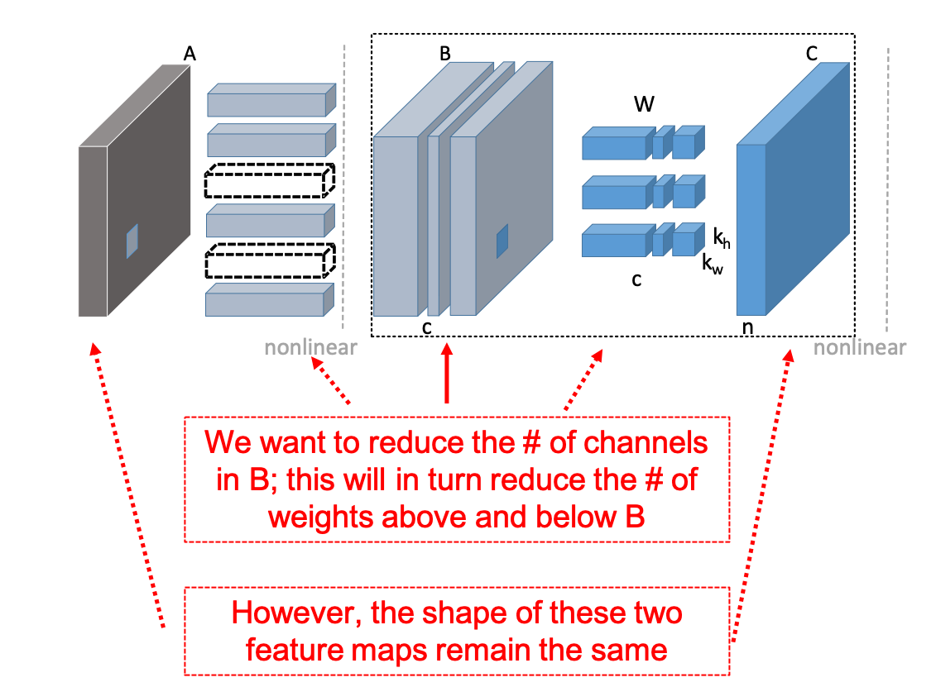

Figure 5: My interpretation of the concept of pruning the channel. The original figure is from Figure 2 in He et al. (2017).

The central thinking in this category is to find out the correct criteria for pruning. I will list three related publication here.

**(2.2.1) Molchanov et al. (2017)**

Molchanov et al. (2017) used Taylor expansion (denoted as TE). Put in simple language, what they did was simply looking at parameters (in practice, they looked at feature maps) that have the least contributions to the degrading of the cost function. Figure 6 shows my interpretation of their main equation (eqn 5). It is important to note that both the activations and the partial derivatives can be easily tracked from the standard back-propagation procedure. Therefore, I personally think the extra computing cost is quite minimal for this method.

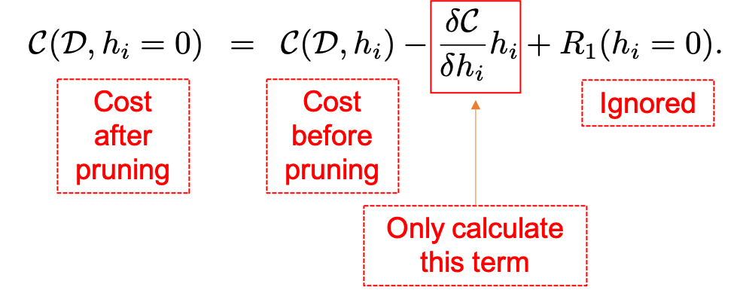

Figure 6: My interpretation of the selection criteria from Molchanov et al. (2017). Note that only the derivative term is looked at.

The full equations are their equations (7) and (8), which are copied here:



where the $Θ_{TE}:R^{H×W×C}→R^{+}$ is the target function to be minimized. And for a feature map, we simply sum over all the values:



For fine tuning, Molchanov et al. (2016) appears to retrain the network although details were not clear from their descriptions.

**(2.2.2) He et al. (2017) – Inference only**

The next two papers have similar criteria, which try to maintain the outputs in feature maps. Their criteria are copied here:



where X has a dimension of $N×c×H×W$, W has a dimension of $n×c×H×W$, c and n are the number of input and output channels respectively, and Y is the output feature maps. The coefficients $β$ determine how each channel is selected. They solve these coefficients by LASSO regression, which I am not familiar with and hard to comment on the speed.

It is worth pointing out that after the $β$ are solved and fixed, the authors perform an extra step to refine the weights W by solving a simple least square problem:



where the prime denotes the weight/feature map after pruning.

Somewhat unexpected and contrary to He et al. (2015)’s finding, this paper suggested that the deeper conv layers are more sensitive to pruning than the shallower ones (Figure 7). It is still unclear to me why this is the case.



Figure 7. Single layer performance analysis. This is copied from Figure 4 in He et al. (2017).

**(2.2.3) Luo et al. (2017)**

This is very similar to the previous method. Their criteria are again to try to maintain the output layer, but this time by randomly selecting a subset of the values in the output map and performing a greedy minimization. Details are as follows:



Figure 8: Illustration of Luo et al. (2017)’s method. This is copied from Figure 2 in Luo et al. (2017).

One output y can be written as:



If redefined:



It can be simply as:



where . In simple language, it means the output y is simply a sum of x calculated in different channel (remember the definition of dot product.)

Then one can minimize:



And the above problem is solved by a greedy method described in:



Algorithm 1: Luo et al. (2017). This is copied from the Algorithm 1 in their paper.

Again, some reconstruction is preferred:



and this can be solved easily.

Since this paper includes both inference and inversion, I think it is worth going into some details about performance.

First, the authors tried using different criteria and compared the end results (Figure 9). This is for VGG-16-GAP model pruned on CUB-200 bird data (GAP means replacing the fully connected layer with global average pooling). The ThiNet proposed here outperforms all the other criteria. It is interesting to note that simple random selection is actually pretty good in many cases, although it can fail badly in some other cases, which makes random selection not practical.



Figure 9: Performance comparison. This is copied from Figure 4 in Luo et al. (2017). Random means randomly selecting channels. Weight sum and APoz are two other previously used selection criteria. w/o w means without the aforementioned reconstructions of weights.

Now to a more sophisticated one with VGG-16 on ImageNet. The comparison is in Table 1. A few things are worth pointing out. Firstly, the drop of parameters from replacing FC layer with GAP is huge, but the decrease in FLOPS is quite minimal. Secondly, the drop in FLOPS is not proportional to the drop in calculation time, but in the same direction (i.e. a drop in FLOPS reduces time, although not in the same proportion). Thirdly, while ThiNet-GAP only performs 1/3 of FLOPS compared the original model, the accuracy drop is only ~1%. Lastly, ThiNet-Tiny has more FLOPS than the SqueezeNet, but it actually runs faster. This shows again the importance of maintaining a “regular shape” in network design.



Table 1. Effect of pruning on performance. This is copied from Table 1 in Luo et al. (2017). This is VGG-16 on ImageNet. f./b.: forward and backward timing in milliseconds. ThiNet-Conv: pruning the first 10 conv layers with compression rate of 0.5. Train from scratch: train from scratch based on ThiNet-Conv. ThiNet-GAP: replace the FC layer with GAP, then fine-tuned in 12 epochs. ThiNet-Tiny: prune with a larger compression rate of 0.25.

**3. Quantization**

I personally think this is an interesting area to look at, so I found a few more papers in this section. The main idea is to reduce the bit size of either/both the weight and the activation. The advantages are two folds: one is to decrease the model size, reducing from a typical 32 bit floating-point number to a much smaller bit size; second is to increase the operation speed, especially when reducing down to one bit and bitwise operation is available.

**(3.1) Han et al. (2016) – Look up table**

The first option, as pointed out by Han et al. (2016), is to create a look up table and use K-means to generate the code book. Figure 10 shows the procedure in details. Maybe due to the complexity in implementation and the difficulties in getting the derivatives, I didn’t find too many follow-ups on this idea though.



Figure 10: Schematic plots showing the weight sharing scheme in Han et al. (2016). This is copied from Figure 3 in their paper. The clustering is done by K-mean.

**(3.2) Jacob et al. (2017); Wu et al. (2018) – 8 bit Integer**

This seems to me has already been implemented in TensorFlow Lite and a more well written article can be found here: <https://heartbeat.fritz.ai/8-bit-quantization-and-tensorflow-lite-speeding-up-mobile-inference-with-low-precision-a882dfcafbbd>. I therefore will not go into the details here.

**(3.3) Simons and Lee (2019) – review paper on binarized network, i.e. 1 bit**

I would like to jump to binarized network since many concepts described here can be generalized to the next sections (3.4 and 3.5). Simons and Lee (2019) gave a very thorough overview on the development of this so called “Binarized Neural Networks” (BNN), which represents both weight and activation using only one bit, i.e. either +1 or -1.

However, the statement above in many cases seems to be “cheating”, because in the underlying training step, the 32 bit weights need to be stored and most schemes update these 32 bit weights. Even at the inference step, although many of the weights/activations are in binary, intermediate scaling factors etc. are still in 32 bits. Despite of all these “pitfalls”, the binarized networks still attract many attentions in the field. The fundamental difficulties lie in quantizing the weights/activations and calculating their derivatives. I will therefore break this into two parts in (3.3.1) and (3.3.2). Some comments on the performances are in (3.3.3).

**(3.3.1) Approximating the derivatives**

I think Figure 11 and Figure 12 can provide a unified understanding. In my opinion, one can think of the quantization as one extra layer in the network. The forward pass is easy, which is normally just doing a sign function, or a variant of it. The difficulty is in the backward pass, i.e., calculating the derivative of this layer. I found Figure 12 to be very informative in this aspect, essentially showing what actually happens, i.e. how to approximate a delta function.



Figure 11: A conceptual model of the quantization process. This is copied from Figure 1 in Simons and Lee (2019). WR is the real weight and WB is the binary weight. Note that the quantization layer (depicted by the pink box) does not always need to be the sign function.



Figure 12: Forward and backward approximation for the quantization layer. This is copied from Figure 4 in Darabi et al. (2019). (Top-left) Exact representation; (Top-right) The approximation used by Courbariaux et al. (2016), which is considered the original BNN. (Bottom left) and (Bottom right) Two approximations used in Darabi et al. (2019) for the SignSwish function.

To be specific, in earlier work (e.g. Courbariaux et al. 2016), one would use



where aR is the activation in 32 bits and aB is the binary version. The indicator function penalizes large activation. Similar procedure is also usually done for the weights to keep them between -1 and +1.

In BNN+ (Darabi et al. 2019), the SignSwish function was used



to represent the quantization layer. The shape of this function can be seen in Figure 12. The novelty of this function is that it essentially alleviates the difficulty of calculating derivatives, and all techniques from normal CNN can be used.

**(3.3.2) Quantizing the weights/activations**

The simplest way is, of course, a sign function as done in Courbariaux et al. (2016). However, significant improvement on accuracy can be obtained by using more basis as shown by the ABC Net (Lin et al. 2017), which has the highest accuracy in models I have found so far.

In ABC Net, the real weight W is approximated by



where the Bs is only +1 or -1 and are defind by:



the u can be learned from the network or simply specified as:



In my understanding, the above procedure is doing the following (though not exactly because ui is found arbitrarily here):

-1.1 = -1 - 0.1 * 1

-0.9 = -1 + 0.1 * 1

0.9 = 1 – 0.1 * 1

1.1 = 1 + 0.1 * 1

which I can present 32 bit weights of -1.1, 0.9, 0.9 and 1.1 using only two binary bits, and with $α_{1}$ =1.0 and $α_{2}$ =0.1. It is also worth comparing this linear quantization with the log base quantization described in (3.5).

Once the quantization layer is given concretely, the forward and backward pass is straightforward:





For activation, the authors first define



and



which are the functions to turn a real number (R) to either -1 or +1.

To fully represent the real activation and similar to the weights, the authors used



where the As are



the authors leave the v and $β$ to be trained by the network.

An illustration is given in Figure 13 and note that now the convolution can be done by bitwise operations and a linear combination in the end.



Figure 13: Illustration of the binary convolution. This is copied from Figure 1 in Lin et al. (2017). Note the BinConv layer can be implemented using bitwise operations.

**(3.3.3) Performances**

Some performance statistics can be found in Table 2. Note that the accuracy of ABC-net is by far the best (probably except Tang et al. 2017 which I haven’t read yet ☹) and only a few percent less than the Full Precision version. The ABC-net used cited here uses 5 binary bits for both the weights and the activations. It is somewhat frustrating that no actual computing time data are compiled here so it is hard for me to judge on that aspect.

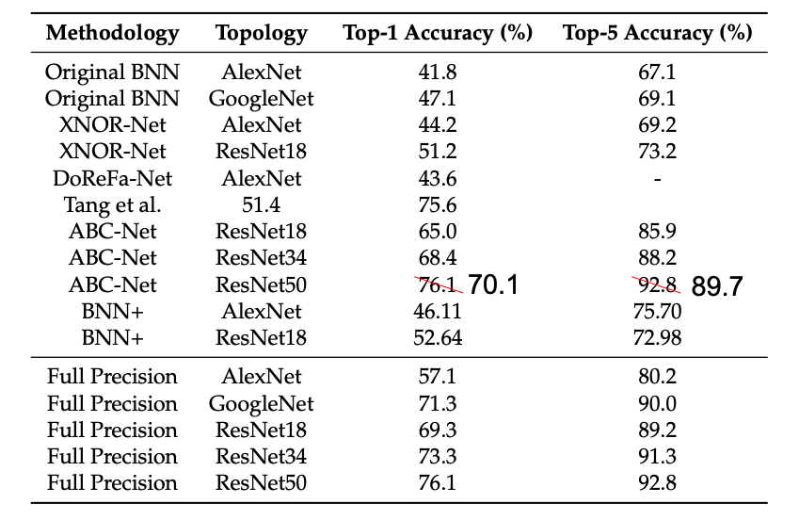

Table 2: Performances for a few binary networks. This is copied from Table 3 in Simons and Lee (2019) after correcting a key error in the accuracy for ABC-Net using ResNet50.

There are also other aspects to be considered, e.g. the padding (0 is not -1 or +1), regularization, BN and etc. Due to the limitation in time and space, I will instead point the readers to Simons and Lee (2019) for further discussions.

**(3.4) Zhu et al. (2017) – Ternary bits**

Once we have a clear understanding of the Binary network, the ternary version should be fairly straightforward to understand. The quantization is as follows:





and an illustration is given in Figure 14.



Figure 14: Illustration of the Ternary quantization in Zhu et al. (2017). This is copied from Figure 1 in their paper.

However, when compared to the approximation schemes in Figure 12, it seems to me the approximation of derivatives is somewhat problematic (Figure 15). Some feedbacks or discussions on this are welcome.

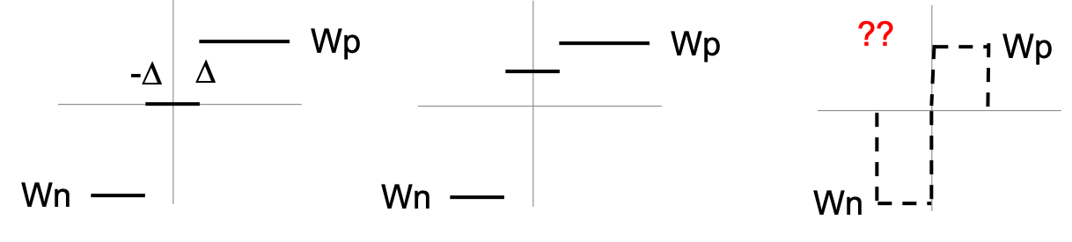

Figure 15: A problem in the Zhu et al. (2017)? The left panel shows the quantization layer. The middle panel shows the derivatives used in their paper to approximate that layer. However, I think the right panel is the right one for the derivatives.

**(3.5) Miyashita et al. (2016) – Log base**

This is a fairly interesting proposal since it claims to be able to use quantized gradients in the training, i.e. it can use quantized numbers end-to-end.

To begin with, the dot product can be computed as:



and the quantization is done either using log or linear base:



or



FSR represent the full scale range and is specified beforehand.

The effect of quantization is shown in Figure 16:



Figure 16: Distribution of the activations of conv2_2 layer in VGG16. This is copied from Figure 2 in Miyashita et al. (2016). The top two panels show the linear scheme and the bottom two panels show the log scheme.

As mentioned before, the most interesting part is the training with quantized gradients (Figure 17). A few observations are made here: Firstly, the log quantization scheme using 5 bits perform very close to the full precision version, either with quantized or unquantized gradients. Secondly, the linear quantization scheme requires storing full precision gradients. Thirdly, the BBN, which requires full precision weights, does not perform as well as the log quantized scheme.



Figure 17: Epoch vs loss and accuracy. This is copied from Figure 7 in Miyashita et al. (2016). The Float 32b can be considered as the full precision version. The log-5b and linear-5b are the quantized version using either log or linear base respectively, but the same 5 bits. The result using unquantized gradients are also shown. It is important to note that the linear-5b unquantized performed poorly.

**4. Architect**

Since network designs were covered in class, I will only briefly review one of the latest developments ShuffleNet v2 (Ma et al. 2018). This paper also gave a very informative explanation for the design principles that I think are worth repeating in this review:

Design principles:

G1) Use equal channel width. The authors use 1 x 1 convolution as example. Assume the input feature map has a size of h x w, the input channels is c1 and the output channel is c2, under a fix FLOPs of B = hwc1c2, one can estimate the memory access cost (MAC) by adding the memory access to the input/output feature map and the kernel:

$$MAC=hw{(c}_{1}+c_{2})+c_{1}c_{2}≥2hw\sqrt{c_{1}c_{2}}+c_{1}c_{2}=2\sqrt{hwB}+B/hw$$

where the lower bound is reached when c1=c2.

G2) Excessive group convolution increases MAC.

Similar to the derivation above, assume we have g groups:

$$MAC=hw{(c}_{1}+c_{2})+\frac{c_{1}c_{2}}{g}=hwc_{1}+\frac{Bg}{c_{1}}+B/hw$$

where B = hwc1c2/g in this scenario. Hence, if g increases, MAC increases.

G3) Network fragmentation hurts.

This is probably intuitive as it reduces the degree of parallelism.

G4) Element-wise operations are non-negligible.

This is somewhat surprising although the authors showed good data to support this claim (Figure 18).



Figure 18: Runtime decomposition. This is copied from Figure 2 in Ma et al. (2018).

Under these guidelines, the structure of ShuffleNet itself is actually not that complicated, and the key is the channel separation block (Figure 19, in their paper, they simply split the input channels into two equal size blocks).



Figure 19: ShuffleNet v1 and ShuffleNet v2. This is copied from Figure 3 in Ma et al. (2018).

The performance of this simple modification is quite good, as shown in Table 3. It is almost the best architect in all aspects, with MobileNet v1 probably coming close.



Table 3. Performances of ShuffleNet v2 vs others. This is copied from Table 8 in Ma et al. (2018).

**4. Conclusion and some thoughts on potential future project**

To summarized, I believe the current developments in pruning, quantization and architect design have dramatically reduce the loss of accuracy when CNN is deployed on mobile devices. Although it is hard to judge the actual computing speed from these papers, I think the time will come that we can do at least very fast inference on mobile devices without sacrificing accuracy.

As mentioned in the introduction, I am interested in developing a basic trash classification app using CNN. I am thinking that a combination of these three aspects might be possible and worth trying. For example, channel pruning seems to be do-able with ShuffleNet v2 in my opinion (Figure 20). In this case, we can prune feature maps between the split operation and the concat operation without changing the input and output shapes. It is not clear to me which quantization method is the best, but at least quantizing with a log basis combined with the SignSwish approximation would be a good starting point. It will be particularly interesting if I can indeed to learning with quantized gradients based on Miyashita et al. (2016).

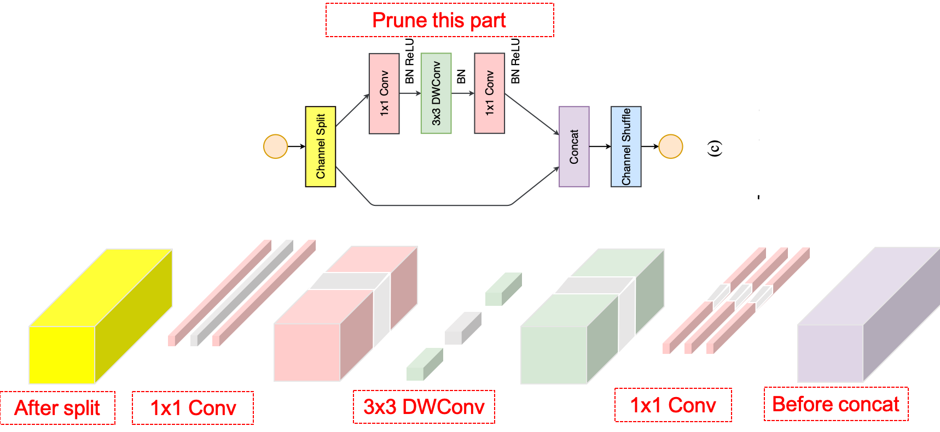

Figure 20. My naïve thoughts on pruning the feature maps in ShuffleNet v2. The grey areas are the places I think can be pruned without changing the shapes of the input and output feature maps.

References

Courbariaux, M., Hubara, I., Soudry, D., El-Yaniv, R., & Bengio, Y. (2016). Binarized neural networks: Training deep neural networks with weights and activations constrained to+ 1 or-1. arXiv preprint arXiv:1602.02830.

Darabi, S., Belbahri, M., Courbariaux, M., & Nia, V. P. (2018). BNN+: Improved binary network training. arXiv preprint arXiv:1812.11800.

Han, S., Mao, H., & Dally, W. J. (2015). Deep compression: Compressing deep neural networks with pruning, trained quantization and huffman coding. arXiv preprint arXiv:1510.00149.

Han, S., Pool, J., Tran, J., & Dally, W. (2015). Learning both weights and connections for efficient neural network. In Advances in neural information processing systems (pp. 1135-1143).

He, Y., Zhang, X., & Sun, J. (2017). Channel pruning for accelerating very deep neural networks. In Proceedings of the IEEE International Conference on Computer Vision (pp. 1389-1397).

Jacob, B., Kligys, S., Chen, B., Zhu, M., Tang, M., Howard, A., ... & Kalenichenko, D. (2018). Quantization and training of neural networks for efficient integer-arithmetic-only inference. In Proceedings of the IEEE Conference on Computer Vision and Pattern Recognition (pp. 2704-2713).

Lin, X., Zhao, C., & Pan, W. (2017). Towards accurate binary convolutional neural network. In Advances in Neural Information Processing Systems (pp. 345-353).

Luo, J. H., Wu, J., & Lin, W. (2017). Thinet: A filter level pruning method for deep neural network compression. In Proceedings of the IEEE international conference on computer vision (pp. 5058-5066).

Ma, N., Zhang, X., Zheng, H. T., & Sun, J. (2018). Shufflenet v2: Practical guidelines for efficient cnn architecture design. In Proceedings of the European Conference on Computer Vision (ECCV) (pp. 116-131).

Miyashita, D., Lee, E. H., & Murmann, B. (2016). Convolutional neural networks using logarithmic data representation. arXiv preprint arXiv:1603.01025.

Molchanov, P., Tyree, S., Karras, T., Aila, T., & Kautz, J. (2016). Pruning convolutional neural networks for resource efficient transfer learning. arXiv preprint arXiv:1611.06440, 3.

Molchanov, P., Tyree, S., Karras, T., Aila, T., & Kautz, J. (2017). Pruning convolutional neural networks for resource efficient inference. arXiv preprint arXiv:1611.06440.

Simons, T., & Lee, D. J. (2019). A Review of Binarized Neural Networks. Electronics, 8(6), 661.

Wen, W., Wu, C., Wang, Y., Chen, Y., & Li, H. (2016). Learning structured sparsity in deep neural networks. In *Advances in neural information processing systems* (pp. 2074-2082).

Wu, S., Li, G., Chen, F., & Shi, L. (2018). Training and inference with integers in deep neural networks. arXiv preprint arXiv:1802.04680.

Zeng, X., Cao, K., & Zhang, M. (2017, June). MobileDeepPill: A small-footprint mobile deep learning system for recognizing unconstrained pill images. In Proceedings of the 15th Annual International Conference on Mobile Systems, Applications, and Services (pp. 56-67). ACM.

Zhu, C., Han, S., Mao, H., & Dally, W. J. (2016). Trained ternary quantization. arXiv preprint arXiv:1612.01064.